Assuming the api-key is *t0p53cr3t4p1k3yv4lu3*, when the application is started like so:

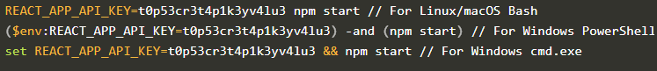

you can access the value of the key from the process.env object:

Note that if you created the application using npx create-react-app ...and you want to use a different name for your environment variable then the environment variable name must still begin with REACT_APP_. You can also use a .envfile rather than defining it on the command line each time by creating a file entitled '.env' in the root of the project and adding the following.

Note that you will need to restart the server to apply the changes.